# Challenge 5 - JavaScript & AJAX

For this challenge you will demonstrate your JavaScript skills by building a replica of the [NASA APOD](https://apod.nasa.gov/apod/astropix.html) site using their [public API](https://api.nasa.gov/api.html#apod).

## Resources

* [NASA API Key](https://api.nasa.gov/index.html#apply-for-an-api-key)
* [APOD API](https://api.nasa.gov/api.html#apod)
* [MDN: Date Picker](https://developer.mozilla.org/en-US/docs/Web/HTML/Element/input/date)
* [MDN: progress Element](https://developer.mozilla.org/en-US/docs/Web/HTML/Element/progress)
* [MDN: Images](https://developer.mozilla.org/en-US/docs/Web/API/Canvas_API/Tutorial/Using_images#Creating_an_image_from_scratch)

## Instructions

For this assignment, you will build an interactive version of the NASA APOD site, allowing users to change the date using a date picker.

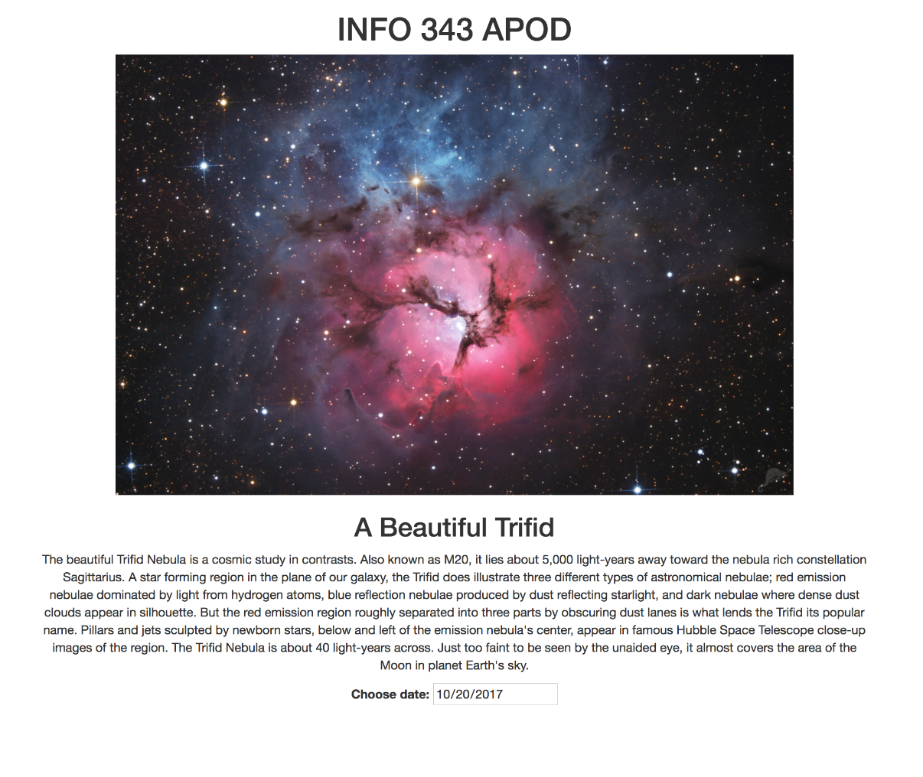

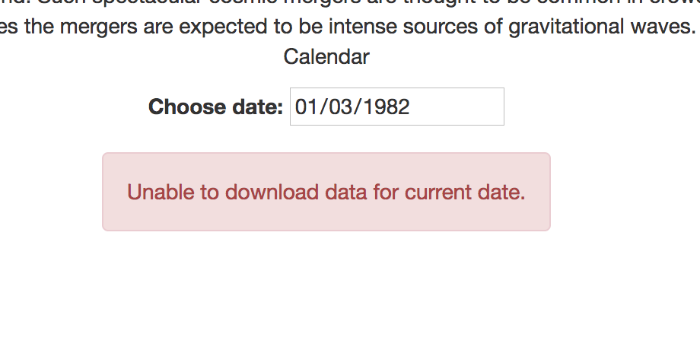

### API Key

In order to use NASA’s APIs, [**you must sign up for an API Key**](https://api.nasa.gov/index.html#apply-for-an-api-key), which you will include as a query parameter each time you make a request:

**Example URL:** https://api.nasa.gov/planetary/apod?api_key=MY_API_KEY&date=2017-09-13

**Example Response:**

{

"copyright": "George Varouhakis",

"date": "2017-09-13",

"explanation": "Nebulas are perhaps as famous for being identified with familiar shapes as perhaps cats are for getting into trouble. Still, no known cat could have created the vast Cat's Paw Nebula visible in Scorpius. At 5,500 light years distant, Cat's Paw is an emission nebula with a red color that originates from an abundance of ionized hydrogen atoms. Alternatively known as the Bear Claw Nebula or NGC 6334, stars nearly ten times the mass of our Sun have been born there in only the past few million years. Pictured here is a deep field image of the Cat's Paw Nebula in light emitted by hydrogen, oxygen, and sulfur.",

"hdurl": "https://apod.nasa.gov/apod/image/1709/ngc6334_Varouhakis_1200.jpg",

"media_type": "image",

"service_version": "v1",

"title": "NGC 6334: The Cat's Paw Nebula",

"url": "https://apod.nasa.gov/apod/image/1709/ngc6334_Varouhakis_960.jpg"

}

### Requirements

#### A. Today’s Image

1. When the page loads, it must display today’s picture, title, and explanation from the APOD API.
2. A user should not be able to select a date from the date picker that is in the future.
3. The currently selected date in the date picker should be initially set to today’s date.

### B. Changing the Date

1. When the user selects a different date, the page should load the APOD image, title, and explanation for the selected day day.
2. While the page is downloading the new data, a progress bar should be shown on the page. It should be visible until the image has completed loading (or until an error message is displayed).
3. While the page is downloading the new data, the date picker should be disabled until API request has completed.
4. If there is an error downloading the new data, an error message should be displayed.

### C. Styling

1. Overall styling of the page is up to you, but the page should be formatted and styled with more than just the default browser styling.

### D. Libraries

1. For this assignment, you may not use a third-party library (such as jQuery) to make your AJAX requests.
2. You may use the fetch API instead of XMLHttpRequest.

### E. Extra Credit

1. **Styling** (10 points): Make your page look out of this world.

### Validate your code

Use the [HTML Validation Service](https://validator.w3.org/#validate_by_upload) to validate your HTML and fix any errors or warnings that are reported. The report should contain specific instructions and/or links that will help you fix the problems.

Also use the [CSS Validation Service](http://jigsaw.w3.org/css-validator/#validate_by_upload) to validate your CSS and fix any errors or warnings that are reported.

**We will run your HTML and CSS through these validators and you will lose points if any errors/warning are reported!**

### Commit your files

Whenever you complete some work that you want to commit, add all your changed files to your local git repo, commit the changes, and push your challenge5 branch to GitHub. Include a sensible commit message so that other developers (including us) can understand what changed in this commit.

### Publish to GitHub Pages

To publish your page to the web, create a new branch in your repo named gh-pages, and merge all commits you’ve made to the challenge5 branch into the gh-pages branch. Then push this new gh-pagesbranch to GitHub. After the push is complete, you should be able to see your page at the following URL, replacing your-github-username with your GitHub user name.

https://info343a-au17.github.io/challenges-your-github-username/challenge5/

You can do this directly on your personal computer before pushing to Github, i.e. you do not need to use a pull request to merge your code in the gh-pages branch.

Rubric

**Challenge 5**

| Challenge 5 | | |
| --- | --- | --- |
| **Criteria** | **Ratings** | **Pts** |
| This criterion is linked to a Learning OutcomeA1. When the page loads, it must display today’s picture, title, and explanation from the APOD API. | |  |  | | --- | --- | | Full Marks  20.0 pts | No Marks  0.0 pts | | 20.0 pts |
| This criterion is linked to a Learning OutcomeA2. A user should not be able to select a date from the date picker that is in the future. | |  |  | | --- | --- | | Full Marks  5.0 pts | No Marks  0.0 pts | | 5.0 pts |
| This criterion is linked to a Learning OutcomeA3. The currently selected date in the date picker should be initially set to today’s date. | |  |  | | --- | --- | | Full Marks  5.0 pts | No Marks  0.0 pts | | 5.0 pts |
| This criterion is linked to a Learning OutcomeB1. When the user selects a different date, the page should load the APOD image, title, and explanation for the selected day day. | |  |  | | --- | --- | | Full Marks  15.0 pts | No Marks  0.0 pts | | 15.0 pts |
| This criterion is linked to a Learning OutcomeB2. While the page is downloading the new data, a progress bar should be shown on the page. It should be visible until the image has completed loading (or until an error message is displayed). | |  |  | | --- | --- | | Full Marks  10.0 pts | No Marks  0.0 pts | | 10.0 pts |
| This criterion is linked to a Learning OutcomeB3. While the page is downloading the new data, the date picker should be disabled until API request has completed. | |  |  | | --- | --- | | Full Marks  10.0 pts | No Marks  0.0 pts | | 10.0 pts |
| This criterion is linked to a Learning OutcomeB4. If there is an error downloading the new data, an error message should be displayed. | |  |  | | --- | --- | | Full Marks  10.0 pts | No Marks  0.0 pts | | 10.0 pts |
| This criterion is linked to a Learning OutcomeC1. Overall styling of the page is up to you, but the page should be formatted and styled with more than just the default browser styling. | |  |  | | --- | --- | | Full Marks  15.0 pts | No Marks  0.0 pts | | 15.0 pts |
| This criterion is linked to a Learning OutcomeHTML, CSS is valid | |  |  | | --- | --- | | Full Marks  5.0 pts | No Marks  0.0 pts | | 5.0 pts |
| This criterion is linked to a Learning OutcomePublished to Github Pages | |  |  | | --- | --- | | Full Marks  5.0 pts | No Marks  0.0 pts | | 5.0 pts |
| This criterion is linked to a Learning OutcomeExtra Credit: Styling (10 points) | |  |  | | --- | --- | | Full Marks  0.0 pts | No Marks  0.0 pts | | 0.0 pts |
| Total Points: 100.0 | | |